Combating Climate Change

Table of Contents
Overview 2
Issues 2
Initiatives 3
UAE National Climate Change Plan 3
The UAE Green Agenda Programs 2015-2030 4
Carbon Capture and Storage 5
Impact 6
Conclusion 7

Overview
Changing weather patterns, rising sea levels, extreme weather events and high levels of greenhouse gas emissions indicate to us that climate change is a serious factor affecting the world. United Nations Sustainable Development Goal 13 is Climate Action that provides a goal and encourages countries around the world to take action with ambition and urgency enabling their economies to become resilient by adopting affordable and scalable sustainable solutions that combat the effects of climate change.

The UAE Sustainable Development Goals focuses on action taken for climate change and its impacts. To reinforce the same, UAE has formed a Council for Climate Change and Environment, a council whose focus will be on the UAE’s policies and strategies for creating effective initiatives that tackle climate change enabling environmental and sustainable development. UAE has also renamed the Ministry of Environment and Water to the Ministry of Climate Change and Environment highlighting the importance of climate change and enabling the ministry to manage issues and initiatives relating to climate change.

“Our goal is clear: to build an economy that protects the environment and an environment that supports the growth of the economy.”
HIS HIGHNESS SHEIKH MOHAMMED BIN RASHID AL MAKTOUM
Vice President and Prime Minister of the United Arab Emirates
Ruler of Dubai
Source: National Climate Change Plan 2017-2050

Issues
The United Arab Emirates is vulnerable to climate change events like:
- Warmer weather
- Less precipitation
- Droughts
- Rising sea levels
- Storms

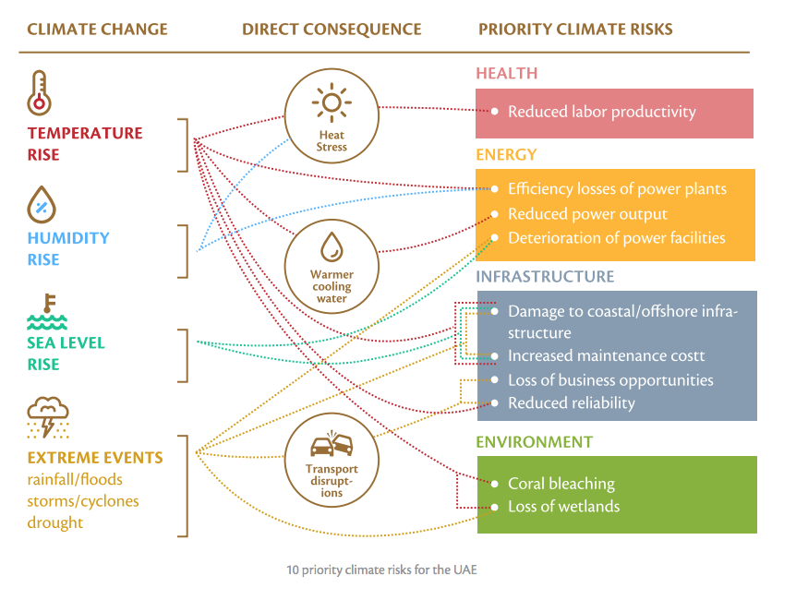
Source: Ministry of Climate Change and Environment

Initiatives

UAE National Climate Change Plan
The National Climate Change Plan 2017- 2050 was launched to ensure that national policies, strategies and initiatives have integrated climate change measures. It serves as a roadmap to encourage people across the nation to take action for climate mitigation. Some of the highlights of the UAE National Climate Change Plan are:

- Adoption of the Paris Agreement at United Nations Framework Convention on Climate Change (UNFCC) in Paris in 2015.
The Paris Agreement will govern climate action from 2020 onwards. It has an ambitious target for both developed and developing countries to hold the global temperature increase to below 2 degrees Celsius compared to pre-industrial levels (the baseline levels maintained before the Industrial Revolution around 1750).

- Launched the Dubai Declaration on Sustainable Finance

The Dubai Declaration on Sustainable Finance was launched in the United Nations Environment Programme – Finance Initiative (UNEP-FI) 2016 Global Round Table. This showcases the commitment of the UAE government to create a drive towards green and sustainable finance by establishing strategic partnerships with financing institutions to bring about a fundamental change and help organizations actively involved in creating innovative solutions combating climate change effects.

- Issuing relevant policy documents such as:
  - National Energy Plan for 2050
  - National Biodiversity Strategy and Action Plan
  - Abu Dhabi Economic Vision 2030
  - Abu Dhabi Environment Vision 2030
  - Dubai Integrated Energy Strategy 2030
  - Dubai Carbon Abatement Strategy 2021
  - Dubai Municipality Climate Change Policy Statement.

The climate plan is a complementary framework of actions that specifically addresses climate change in a proactive manner.

The UAE Green Agenda Programs 2015-2030
A number of programs under a national green growth framework titled Green Agenda 2015-2030 have been implemented with an aim to:
- Create a competitive knowledge economy
- Improve social development and quality of life
- Create a sustainable environment valuing natural resources
- Generate clean energy
- Ensure sustainable use of resources.

The Global Green Growth Institute (GGGI) has partnered with UAE to create the Green Agenda 2015-2030. GGGI has been working with the UAE government to prioritize actions that enhance institutional capacity to address climate change enabling
emissions reductions and adaptation. The country’s total GHG emissions were estimated at 74.4 metric tons of carbon dioxide equivalent (MTCO2e) in 1994 and 201.6 MTCO2e in 2015.

In the near future, the government aims to develop a clearer path toward achieving GHG (Green House Gas) emissions reductions and a single methodology for measurement and reporting. Emissions will be better monitored and the UAE’s ability to adapt to climate change will be strengthened. The UAE’s strategies to reduce GHG are listed below in the picture:

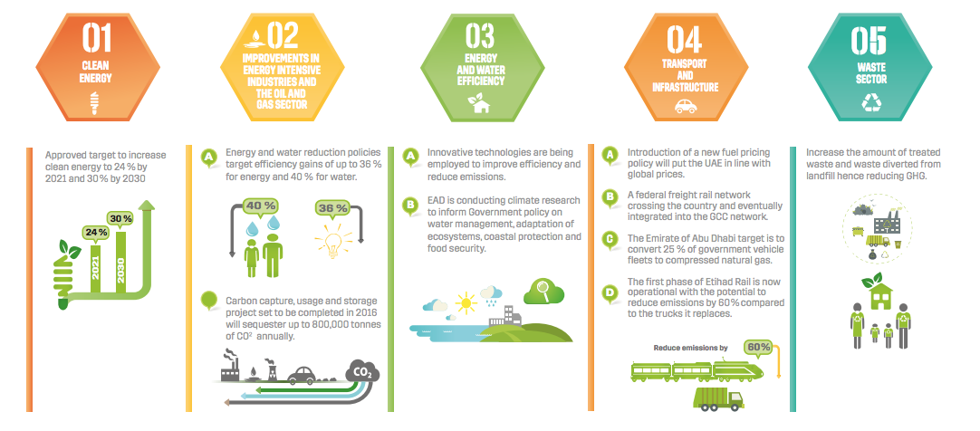
Source: Abu Dhabi State of Environment Report 2017

Carbon Capture and Storage
The Carbon Capture and Storage Association defines Carbon Capture and Storage (CCS) as a technology that can capture up to 90% of the carbon dioxide (CO2) emissions produced from the use of fossil fuels in electricity generation and industrial processes, preventing the carbon dioxide from entering the atmosphere.

Recognizing the increasing importance of CCS technology, UAE has demonstrated viable commercial solutions for CSS to limit industrial emissions through its Al Reyadah facility, a joint venture between the Abu Dhabi National Oil Company (ADNOC) and Masdar, Abu Dhabi’s Future Energy Company. Al Reyadah is touted to be the world’s first commercial Carbon Capture Utilisation and Storage (CCUS) facility for the steel industry.

Emirates Steel was the source of 1% of the UAE’s total CO2. By implementing the carbon capture program 800,000 tonnes of CO2 a year were isolated from the plant. The captured carbon dioxide is injected into Abu Dhabi’s maturing oil fields, replacing natural gas, to enhance oil recovery, where it remains trapped underground.

UAE has ratified international treaties governing cooperation on reduction of
greenhouse gas emissions and for follow-up agreements such as the Paris Agreement and the Kyoto Protocol by the UN Framework Convention on Climate Change (UNFCCC) for CCS technology.

UAE is also part of Clean Energy Ministerial which is a high-level forum grouping 23 countries on clean energy. In 2014, the CCUS programme was closed and transferred to the Carbon Sequestration Leadership Forum which develops and coordinates CCS policies in communications, research, deployment and financing.

Impact
With various initiatives underway and the UAE government’s active participation to mitigate the impact of climate change, REmap 2030 report estimates the UAE to go from 10 megawatts (MW) of solar photovoltaic power in the UAE in 2009 to over 60 gigawatts (GW) by 2032. In addition, there will be an increase in renewable energy that can offset fossil fuels as indicated in the chart below:
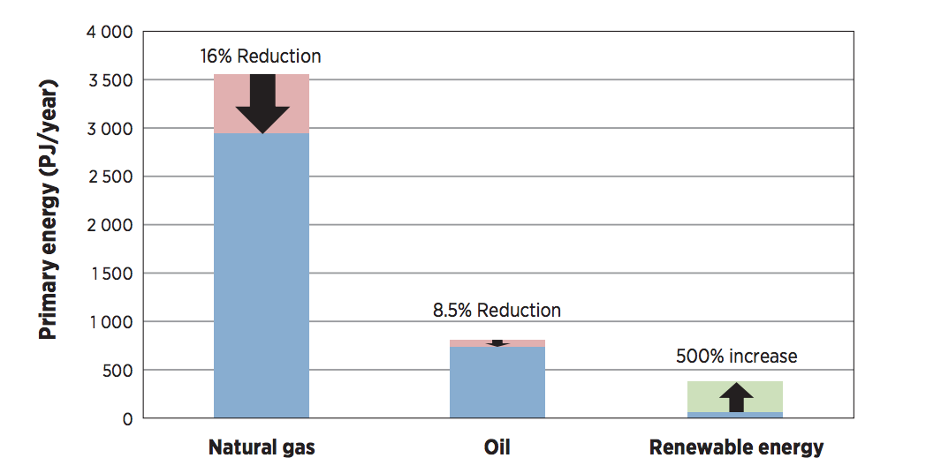
Source: IRENA

Conclusion
Transformation of the UAE to a climate-resilient economy is of high importance
as outlined in the UAE Vision 2021. Focused initiatives on a systematic and scientific assessment of climate risks and vulnerabilities combined with effective implementation of innovative ideas will be the ultimate success of the climate plan. It emphasizes the need to protect people and ecosystems against climate-related impacts.
UAE continues to invest in non-oil sectors and focus on combating climate change and its impact. Deploying resource-efficient, innovative measures will encourage job creations in businesses that focus on clean energy and leverage the mutually reinforced relationship between climate action and economic diversification.

